Bike Controller ADS1115 PCB Testing Report

1. Project Information
- Project: Bike Controller ADS1115 PCB Testing with EM-100 Motor Controller
- Prepared By: M. Ali Rizvi and Maria Tabasum Shoaib
- Test Date: 05/05/2026
- Tested By: M. Ali Rizvi
- Test Environment: Workshop Environment
- Test Stage: Initial Integration Validation

2. Hardware & Firmware Revision
- Hardware Revision: bike-controller-ads1115-hardware-rev-a
- Firmware Revision: bike-controller-ads1115-firmware-v1.1.1
- Controller Model: Votol EM-100
- Battery Configuration: 72V Battery Pack

3. Objective
The purpose of this testing was to evaluate the functionality and performance of the Bike Controller ADS1115 PCB when integrated with the Votol EM-100 motor controller.
The testing also verified the accuracy and reliability of data transmission across multiple interfaces, including the Arduino serial monitor, local web browser, and mobile application.

4. Test Setup

4.1 Hardware and Software Components
The following hardware and software components were used during testing:
- Bike Controller ADS1115 PCB
- Votol EM-100 Controller
- ESP8266 Module
- Arduino Serial Monitor Interface
- Mobile Application
- Local Web Browser

5. Votol EM-100 Configuration Setup
The following section describes the configuration parameters implemented in the Votol EM-100 motor controller using the VOTOL-EM-V3 Software Debugging interface.
The controller was configured for operation with a 72V battery system while maintaining safe operating limits, stable vehicle performance, controlled acceleration, and reliable regenerative braking functionality.
The configuration parameters were finalized after considering:
- Operational safety
- Controller protection limits
- Motor compatibility
- Thermal management
- Rider usability requirements

5.1 Basic System Configuration
The controller model configured was the Votol EM-100 using VOTOL software version 2.33. The system was operated using a 72V battery pack.

5.1.1 Battery Protection Parameters
Parameter | Configured Value
Battery Voltage | 72V
Overvoltage Protection | 91V
Undervoltage Protection | 57V
Soft Undervoltage | 67V
Undervoltage Variation | 1V
These voltage protection settings were configured to protect both the battery pack and controller from unsafe operating conditions such as deep discharge and excessive charging voltage.
The soft undervoltage setting allows gradual power limitation before complete cutoff, improving battery safety and overall system reliability.

5.1.2 Current Limiting Parameters
Parameter | Configured Value
Bus Bar Current Limit | 65A
Controller Current Limit | 50A
The current limits were intentionally restricted to maintain safe thermal operation of the controller and motor system, reduce stress on power electronics, and improve long-term operational reliability.

5.2 Throttle Configuration

5.2.1 Throttle Voltage Parameters
Parameter | Configured Value
Low Protect Voltage | 0.3V
Throttle Start Voltage | 1.24V
Throttle End Voltage | 4.31V
High Voltage Protection | 4.85V
These settings ensure stable throttle operation while preventing unintended acceleration caused by abnormal voltage readings or throttle malfunction conditions.

5.2.2 Throttle Response Parameters
Parameter | Configured Value
Rate of Rise | 200
Rate of Decline | 80
This configuration provides controlled acceleration and smoother deceleration behavior, improving rider comfort and operational stability.

6. Configuration Verification
All configured parameters were verified through the software interface after programming completion. Screenshots of each configuration page, including PAGE1, PAGE2, and PAGE3 settings, are attached in the following sections for configuration traceability and future reference.
6.1 PAGE 1 – Basic Settings

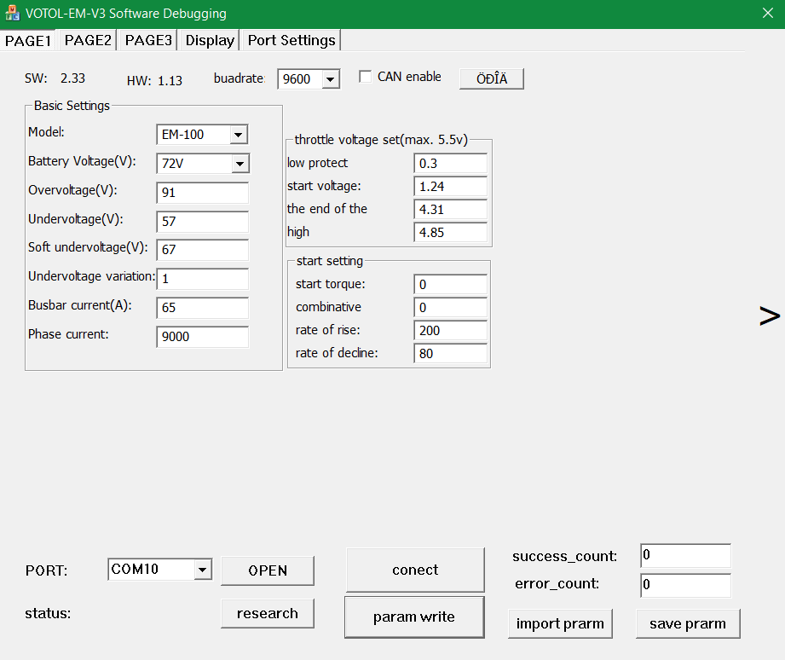

6.2 PAGE 2 – Performance and Speed Settings

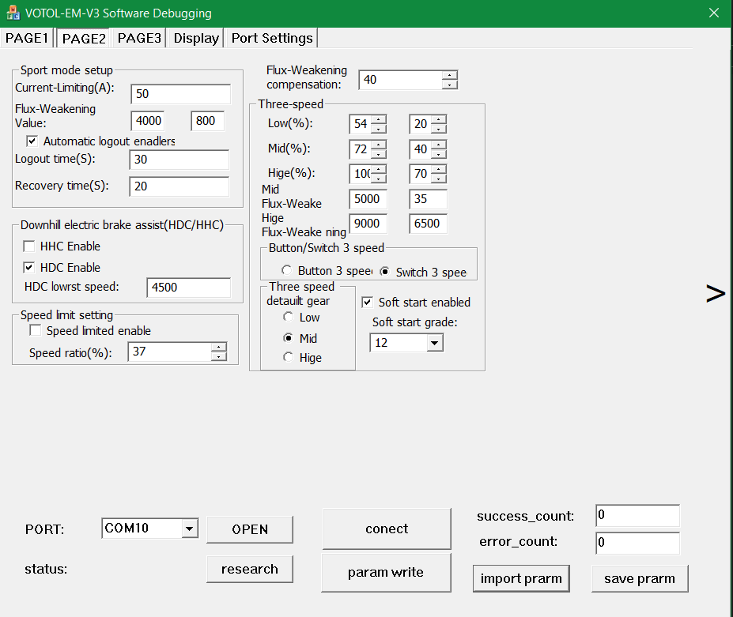

6.3 PAGE 3 – Motor and Safety Settings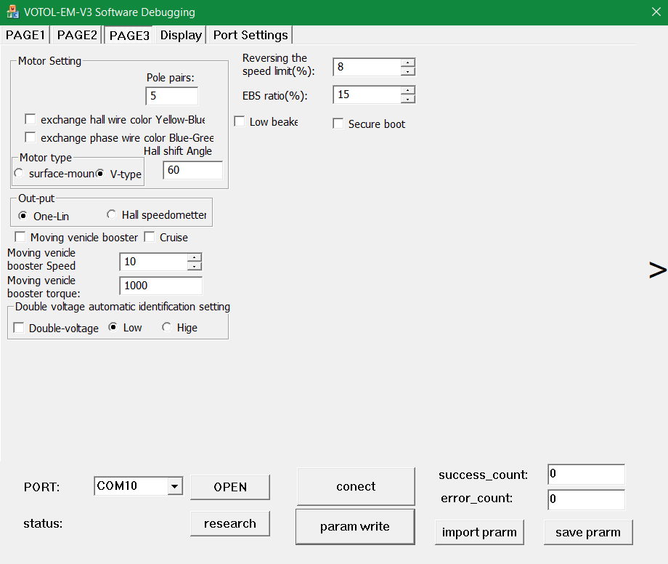

7. Testing Procedure and Observations

7.1 Initial Circuit Testing (Serial Monitor Verification)
The Bike Controller ADS1115 PCB was connected to the bike integrated with the Votol EM-100 motor controller. The vehicle was powered on and testing was performed using the Arduino Serial Monitor interface.
During testing, the following parameters were successfully received and monitored through the serial interface:
- Battery Voltage
- State of Charge (SOC)
- Vehicle Speed
- Average Speed
Screenshots of the serial monitor output were captured and stored for testing traceability and future reference.
The battery voltage reading showed a minor deviation compared to the reference measurement device (multimeter). This deviation is considered acceptable and is attributed to ADS1115 measurement tolerance and voltage divider calibration tolerance.
All monitored parameters were functioning correctly during this testing stage, and stable serial communication was successfully established between the Bike Controller ADS1115 PCB and controller system.
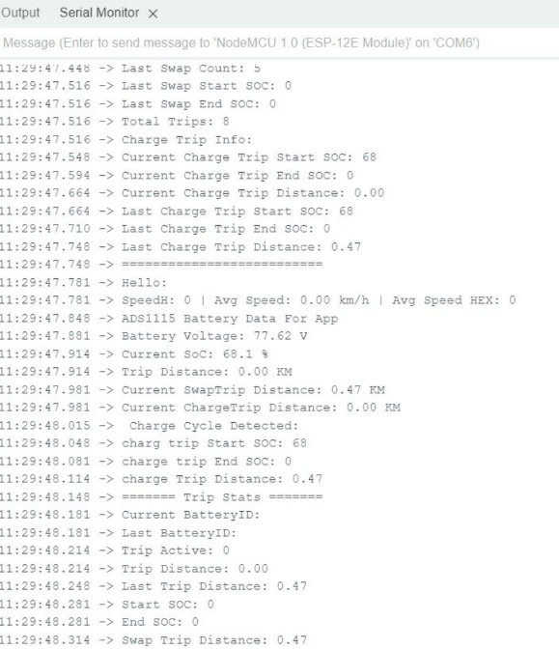
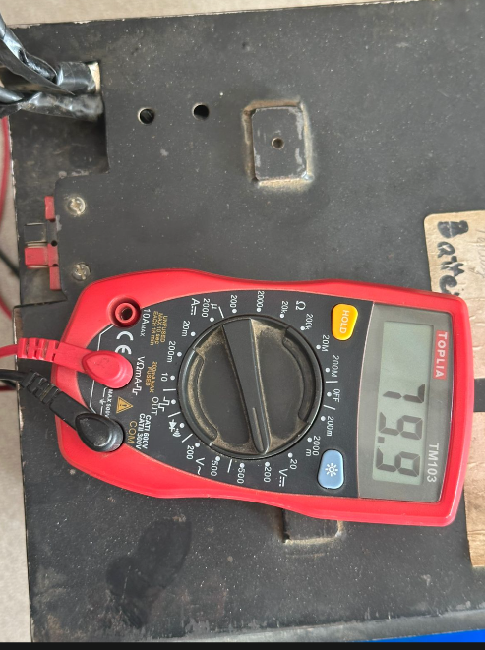

7.2 Mobile Application and Browser Testing
Following successful serial monitor verification, the transmitted data was further tested through the local web browser interface and mobile application.
The following observations were recorded:
- Data from the serial monitor was successfully transmitted to the local web browser
- Browser-displayed values matched the serial monitor output
- The same data was successfully transmitted to the mobile application
- Mobile application readings remained consistent with the serial monitor values
These results confirmed successful communication between the Bike Controller ADS1115 PCB, ESP8266 module, local browser interface, and mobile application.

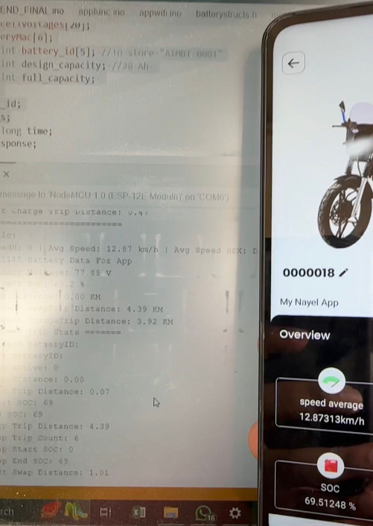

7.3 Identified Issue
A minor issue was identified during mobile application testing:
- Data values on the mobile application were not updating in real time
- Updated values became visible only after manually refreshing the application interface
Based on the testing observations, the issue appears to be related to mobile application refresh handling or application-side data update implementation.
The issue is currently under review by the software development team.

8. Conclusion
The Bike Controller ADS1115 PCB demonstrated satisfactory operational performance during integration testing with the Votol EM-100 motor controller.
All major system parameters, including battery voltage, SOC, speed, and average speed, were successfully measured, processed, and transmitted across all intended interfaces.
Communication between the Bike Controller ADS1115 PCB, serial monitor, local web browser, and mobile application was verified successfully.
The only identified issue was related to real-time data refresh behavior within the mobile application, which is being investigated separately.

